Weather: Cloudy with a chance of meatballs

The most popular newspaper of DC Council
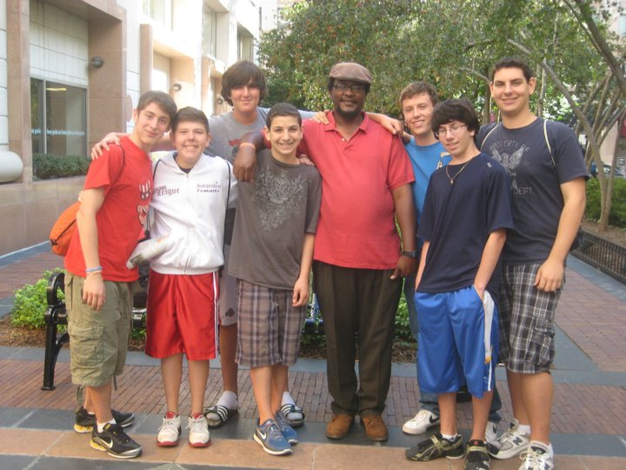
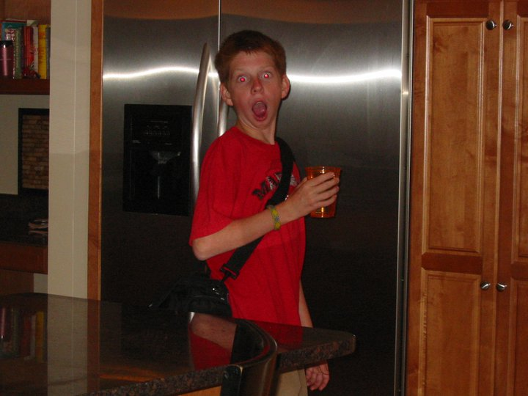

Stocks
Daniel Cooper:

Sam Fregly

-2.7
2
-5.7%

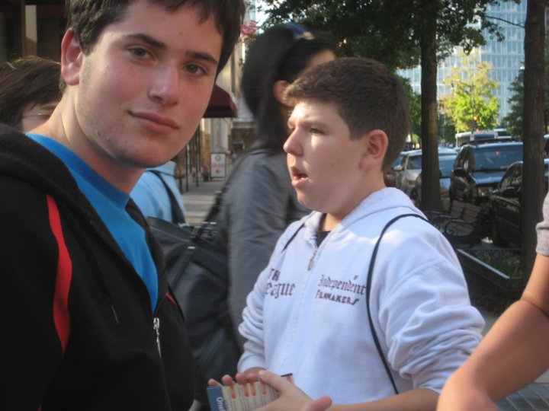
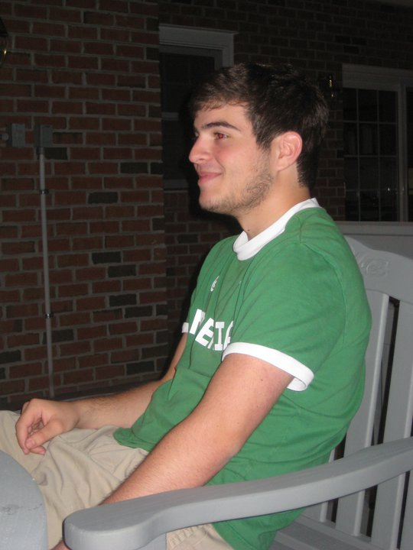
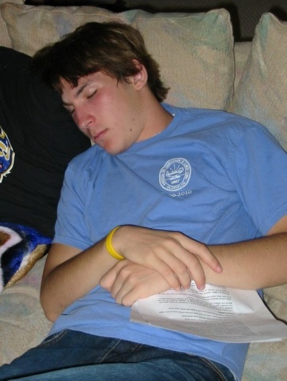
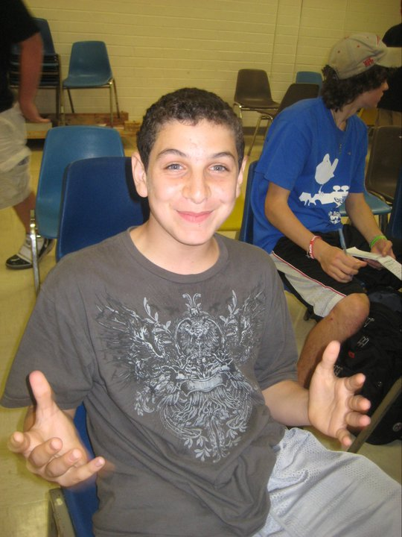
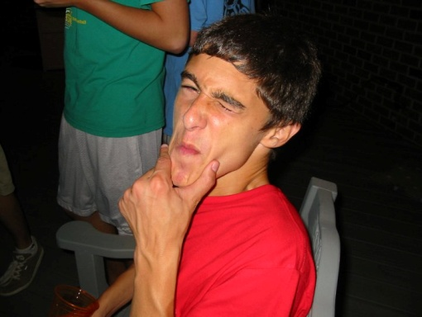
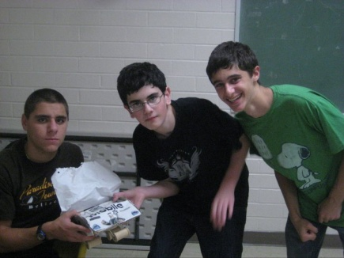
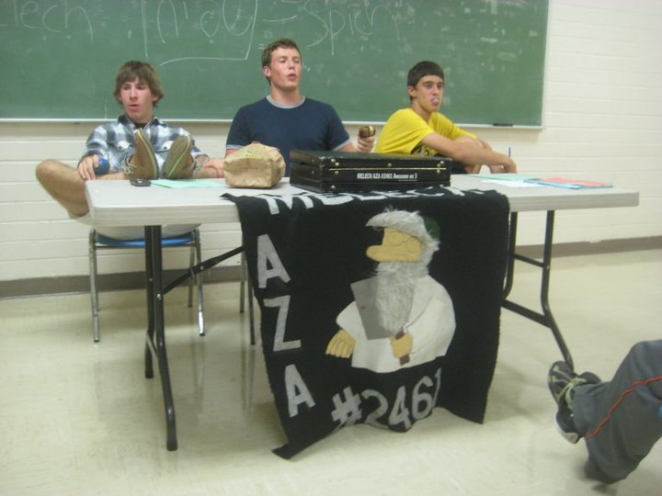
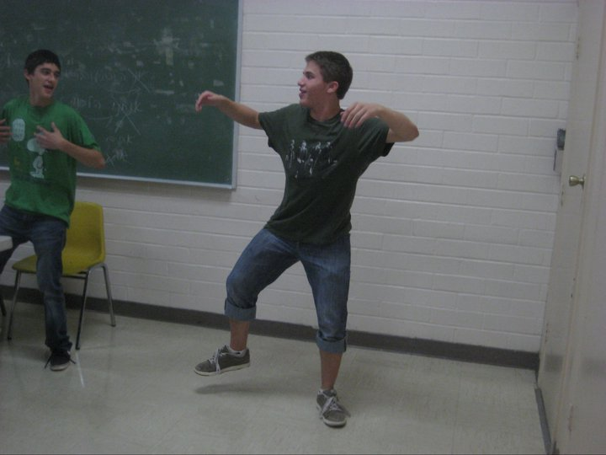
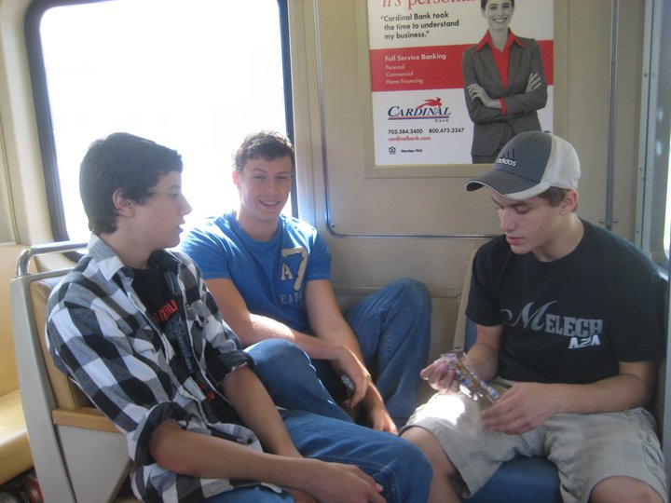
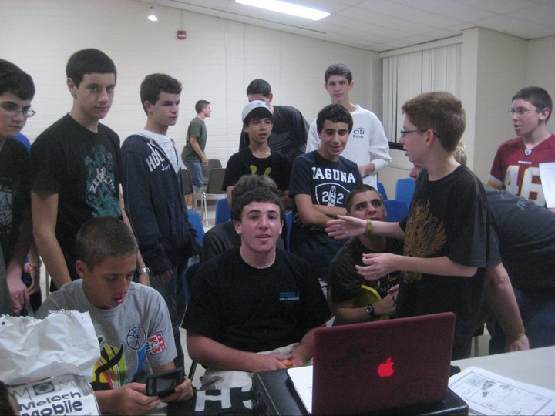

+3.72

+6.3%

Dearest Melech Mohels -
Hello there! In case you have forgotten, my name is Daniel Cooper, and I am proud member of Melech AZA #2461. Over the past few weeks, I have been unable to attend many programs or meetings due to soccer, and for this I apologize. While thinking of what to write, naturally my first choice was to write about how the Wootton varsity soccer team is doing, but I figured id let the Gazette guy do it for me. Enjoy the article on Wootton soccer and how much we sucked this game (for your convenience I have bolded the parts where I am mentioned)
Few boys’ soccer teams in Montgomery County are as talented as Bethesda-Chevy Chase's. But the scoreboard was not showing it.
Until Monday night.
The Barons converted their opportunities in a 3-0 victory over Wootton, which was in first place in the Montgomery 4A East Division. In one game, the hosts matched their scoring output from their first four games combined.
"Honestly, we've just been unlucky," coach Guillermo Melendez said. "Tonight, we still missed a couple, and you don't get those back. If we can put some of them away, we can make that proverbial noise in 4A. ... Our skill level: phenomenal."
Not only are they talented, but they are young. Over half of B-CC's (2-1-2 overall, 1-0-1 4A East) starting lineup consists of underclassmen, and its scoring outburst was entirely generated from three sophomores.
The first goal was the big one, with just over two minutes left in the opening half. Midfielder Collin Martin took a pass from junior Cy McNeil and juked three defenders to get to the end line. Once there, he lofted a cross into the box, where classmate Freddy Nzekele gathered, niftily avoided a Wootton (4-2, 2-1) back, and calmly put it upper 90.
Both players started as freshmen a year ago.
"There was a lot of traffic around me," said Nzekele, who led the Barons with nine goals a season ago. "We just put them away [tonight]."
Conversely, one of the hottest teams in the county could not catch a break. The Patriots had won three in a row, but had not played since their own 3-0 victory over Springbrook on Sept 22.
Rust did not appear to be a problem early, as goalkeeper Daniel Cooper sent an accurate goal-kick to the foot of midfielder Dan Riggio, who hit the left post just five minutes in. The pressure continued throughout the first 15 minutes, but Wootton could never get it going.
The frustration was best summarized on one play midway through the second half, as striker Max Goldschein had a certain goal at his feet inches from the goal line. Instead, he tripped to the ground, not getting a shot off.
Cooper caused the Barons to miss plenty of chances throughout the match, but they eventually cashed in on some beauties. The second was sweet, with sophomore Jimmy Doll sending a through-ball to a wide-open Martin, who put away his chance past the diving Cooper. Late in the game, Martin again dodged defenders in the box, drew a foul and converted the subsequent penalty kick.
"We're not better than we were last year ... but we should always win states," said Martin, a U.S. U-15 National Pool player. "No one was better than us last year, and no one is this year."

Fraternally Submitted with undying love for Melech AZA #2461

Aleph Daniel Cooper

In our tech class last week, we built robots out of legos. On Friday, I walk in and my robot is gone. Nowhere to be found. My teacher proceeds to freak out and ask herself where it could have gone 21 times in a three minute period. My robot is still gone so here are the top 10 places it might be:
10. Out at the JCC founding a new AZA chapter (it’s the thing to do!)
9. Gone to Landover MD, and signed with the Redskins to be their number 1 wide receiver
8. Recording a dope track with new hip hop star, J-Po in his basement/studio.
7. Snuck into Bonnie Katz’s backpack and is trying to boldly go where no robot has gone before
6. Finally caved to the incessant invites to Wootton Soccer games and is lost on the fields of BCC high school (Go Rockets!)
5. Lost on I-95 trying to hitchhike to Queens, New York to see a Childish Gambino show.
4. Took Rick Sanchez’s spot on CNN after Sanchez was fired Friday. Has yet to say something anti Semitic. Well, honestly, it hasn’t said anything at all.
3. Got picked up by the Philadelphia Eagles and is set to start above Michael Vick and Kevin Kolb for Sunday’s game.
2. Snuck backstage at the Drake concert Sunday night and got picked up by Drizzy himself. Drake was quoted saying the combination of legos and wires was “the best I ever had.” The wedding is scheduled for June 2011.
1. Broke out of Wootton but was stopped by the new 5 foot 3 security guard. A fight ensued and the robot emerged victorious but was promptly crushed by the Ride-On bus trying to cross the street.

After years and years of play, conventional sports like basketball, tennis or baseball just seem to get boring. Instead of gathering at the park for another pickup football game, try out some of these options!
11. Cricket. Everyone knows this game as the “Indian Baseball,” but how about actually playing it? Cricket focuses on strategic play instead of the physical strength that is emphasized in baseball.
10. Torball. This sport was originally created for blind people, but now has an expanded community. In Torball, attackers roll a ball into a goal, and defenders rely on sound to locate the ball and knock it away. Helen Keller: benchwarmer.
9. Curling. The mysterious sport that appears on TV during the Olympics is actually quite interesting if you figure out how to play. After honing your skills at any of the few local curling rinks in Montgomery County, you too can go pro on a sport nobody cares about.
8. Korfball. While emphasizing gender equality, Korfball is like Basketball without backboards, dribbling or out of bounds, so skill and teamwork are more important. No meatheads allowed!
7. Quidditch. That’s right—straight out of Harry Potter. The rules are way too complicated to discuss here, but by swapping magical flying brooms and speedy Snitches with earthly objects, Quidditch is definitely playable in real life, and still awesome!
6. Kabaddi. This Hindi sport involves teams wrestling opponents while holding their breath. Don’t get to into it, or suffer the consequences…
5. Sepak Takraw. Volleyball, but instead of using hands and arms, players kick, chest, and knee balls over the net. Also look into Jianzi, which is pretty much badminton, but using feet, not rackets, to whack the shuttlecock.
4. Kho Kho. Tag with rules. Enough said.
3. Roller Derby. Players rack up points skating around an oval track and ramming opponents in what can be described as “Roller Skating Gone Wild!” If you’re not up for playing it, at least explore the underground world of this fast-rising spectator sport. Notable Rollergirls from DC’s Women’s Flat Track Roller Derby League include Guantanamo Babe of the Cherry Blossom Bombshells, Obitchuary of the DC DemonCats, and Condoleezza Slice of Scare Force One.
2. Cycle Polo. While traditionally played on horses, polo on bikes is just so much more practical, and less pompous. Cycle Polo can be played on any given street, and yes, wheelies are legal.
1. Ulama. This is a modern version of Mesoamerican ballgame, which was featured in the classic Disney film, “Road to El Dorado.” Still widely popular in Mexico and other countries, Ulama involves knocking a ball through a hoop with one’s hip. Games can last anywhere between five minutes and several hours, and players get to wear stylish loin cloth-esque gear. Try this one out, and remember to use “the hip, the hip!”

Fraternally submitted with undying love for you,
Aleph Jeff Hilnbrand

My Body Wakes Up
Ears: YOU GUYS! THE ALARM WENT OFF! WAKE UP! WAKE UP!
Brain: Shut. Up.
Ears: Guys! Come on! Arms, go turn it off.
Arms: Um, yeah, I think we’re broken or something, because we won’t can’t move.
Nose: Woah. I smell pancakes. Holy shiatsu. Maybe we should go downstairs.
Legs: No can do, comprendé. We’re not goin anywhere.
Ears: So no one’s gonna turn off the alarm?
Bladder: Guys. I gotta pee.
Brain: Pee in the bed.
Legs: NOT ON US! WE GON’ PEACE ON OUTTA HERE!
Brain: I don’t think so. You’re not going anywhwere.
Bladder: I can’t hold it anymore!
Nose: Guys remember there’s pancakes downstairs!
Tongue: Wow it tastes like morning breath. Ew.
Bladder: Yeah I just peed.
Eyes: We’re going back to sleep.
Ears: Guys? The alarm’s still going off.

Brofully submitted,
Jordan Pories

Most Occurring “Other”: Lucas Lendenbaum

Total Votes: 26

Big B’s Haikus of the Week
By: Big B (Matthew Beinart)
A Warm Welcome
Hey look, what is that
I think it’s an AIT
“Fresh meat” said Lucas
Ballad of a Bird
Yo I saw a bird
It sat on my car today
Get outta here bird
Aight, so haikus are hard as spit, soooo… have any of you seen that Old Spice commercial with Ray Lewis and the talking bear (That’s a great band name…Ray Lewis and the Talking Bear)…Great Commercial. So since this article is already all over the place, I guess I’ll finish with an updated version of my bucket list, soooo…
1. Beat box with Biz Markie
2. Get me a platinum record with Ray Lewis and the Talking Bear
3. Figure out how to add hats to my hippstie look. Me + hats=
Trust me, when I put on a hat I instantly look like Stephen
Baldwin.
4. Learn all the words to “Tootsie Roll” by 69 Boyz
So that’s pretty much it, I think?
Fraternally submitted,
With undying love for AITs, Phish, Pavement, “I am be”, Reggie Watts, but most importantly Melech AZA #2461
Matthew Beinart

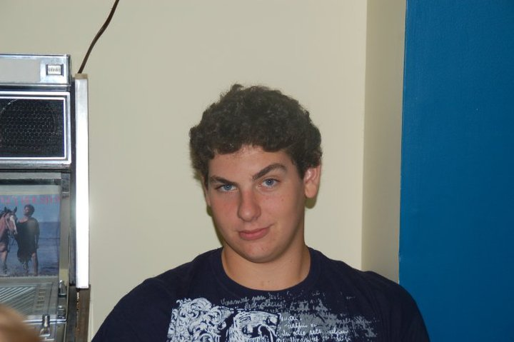
According to Henry David Thoreau, "One is not born into the world to do everything, but to do something." What is your something?
Some say that Maurice Harari was born into this world to do something: "nothing". Clearly these individuals are not well acquainted with the man; the myth; the legend; Maurice Harari.
The man? A mere mortal.
The myth? He beat Chuck Norris in a staring contest.
The legend? Well, that is the elaborate tale that is about to unfold.
Maurice was raised by dragons in a castle in the sky. Maurice can read minds. Maurice has magical powers. Maurice was the President for a day but thought it was too boring so he resigned with no historical record of his term in office ever occurring.
One day, Maurice found a challenge. He always loved a good challenge. As a fetus he solved world hunger. For his Bar Mitzvah he discovered life on Mars. For his sweet sixteen he determined that the Moon is in fact made of Swiss cheese, and put a piece in everyone's goody bag (along with a core sample from his snowed out Quinceañera.) However this challenge was of monumental proportions.
Maurice had noticed that the world was deteriorating due to a lack of cohesiveness between nations, so he snapped his fingers and the world was at peace (Maurice solved world peace!!!) While examining this conundrum, he realized that there was an insufficient amount of renewable resources. This time however, Maurice actually used his superior intellect to devise a solution, but kept the creation hidden from the world for its protection. The world thanked him for his gracious deed, and erected the Island of Mauritania in his honor.
To this day, if you ask Maurice Harari, he'll tell you that he got his engineering degree at the University of Maryland and went on to solve the global energy crisis, but he still thinks this story is way cooler.

MELECH’S 2011 MOTIVATIONAL SPEECH
USING SONGS

Guess who’s back. Melech AZA, It’s that time again. Were back in black and silver. We will start the term off with a bang (bang). All the small things that we do in the chapter have an impact. We must be better than the all other chapters. Our goal is to blow people’s minds and make brain stew. I know everyone will stand by me and be by my side. Chances are we will rock you. But we must come together and not lose control. Look inside yourself, do you have what it takes? Do you remember a time when Melech wasn’t the best? I don’t know why, but I guess perfection comes natural to us. But don’t stop believing. Other chapters are falling, while we are on fire. So follow the godol, the general, the hero, and prepare to get silly. I want you to make this term, the best. So keep it together, Melech. We have no kryptonite. We aren’t leavin’ any time soon. Yeah people say we’re pretty fly, but right now, this, this is just a tribute to Melech’s upcoming term.
Fraternally Submitted with undying love for Melech AZA #2461,
Aleph Ryan Goldberg

Sheboygan Wisconsin: Village of the Year 2010
Written by Scott Steinman
As the leaves fall and the brisk autumn winds pick up, it’s hard to find a frown in this quaint little forest town located in rural Wisconsin. Although fall is just around the corner, the tiny citizens of Sheboygan are already preparing for this year’s winter solstice. To most Americans, the winter solstice has little notable worth, but to the tree dwelling gnomes of Sheboygan Wisconsin, the winter solstice signifies the annual tradition of the Pansy Extermination Day parade. “It all began a mere 307 years ago when the Norse Vikings (Sheboygan ancestry) set up camp in the cozy woodland clearing that is now the fine village of Sheboygan” says local Shoppe-Keep Ermund Kollskegg. “Being a tiny folk, the Vikings became furious when the Pansy flowers blocked the sunlight from their camp site, and began brutally chopping down every Pansy as far as the eye could see.” The Vikings chose this clearing to permanently settle in and as the years progressed and the village grew, chopping down Pansies became a yearly chore that is, until about 42 years ago.
When Roofus Callahan was elected town Mayor in 1968, his brittle gnome ears grew wary of the numerous complaints from the town citizens about the tedious yearly Pansy chopping. Instead of the Winter Solstice bringing groans and sighs, Mayor Callahan helped the Winter Solstice signify celebration. Thus the creation of the Pansy Extermination Day parade! “The Holiday is bushels of fun for the whole family clan” says village wench Helga Grimwick., “but if you don’t keep a close eye on the little ones, they’ll get snatched away by the pigeons!”
Spirits rise and town moral is lifted as the Holiday nears. In every window is an acorn, and the scent of freshly tapped cider wafts through the air. For many Sheboygans, Pansy Extermination Day is not only a tradition, but a source of crucial income. The high demand for goods in preparation of the parade helps even the smallest businesses in town make a profit. “Without the PED parade, my family wouldn’t be able to afford fresh loincloth for the approaching winter or weapons to fend off the army of squirrel bastards that live in the trees” explains lumberjack Thorton Briskwilt. The actual GDP (Gross Domestic Product) of the Pansy Extermination Day parade is approximately $14.11, which somehow lasts optimistic Sheboygan’s 364 days until next year’s parade.
Even with the tallest official citizen standing at 3’6”, Sheboygans don’t seem to have any trouble holding their heads high. “Our wooden clogs give us splinters, and the cruel wrath of mother nature continues to send rodents after our young, but our spirits are always high knowing that we are always 1 day closer to enjoying the Pansy Extermination Day parade” says grammar school teacher Broddi Erikson. The town motto, which can be found engraved upon the newly constructed monument of deceased town Mayor Roofus Callahan, reads “Sheboygan Wisconsin, where our hats are low, but our hopes are high!” This year marks the 42nd anniversary of the parade, and commemorates the Sheboygan lives lost to animal abduction cases.

Fraternally Submitted with undying love for Sheboygan, DA BEARS, not college applications, Tom Sellick, and most of all Melech AZA #2461.
Aleph Bizzatch,
Scott Everett Steinman

New York Mosque: A No Brainer

On September 11, 2001, when nineteen Al-Queda terrorists hijacked American planes and massacred thousands of citizens, a wave of panic and patriotism galvanized the nation. Americans of almost every race and creed united under one common cause to launch a “war on terror”. Now, nine years later, as we mourn the anniversary of this grave, horrific act, an emerging sentiment has surfaced across the nation: a growing resentment towards the Islamic faith. At the height of this antipathic sentiment is a debate which was sparked by recent plans to build a Muslim Community Center and Mosque in New York City near Ground Zero, the sight where the majority of the 9/11 victims lost their lives. This controversy has since been strewn throughout the media and has even been adopted by political platforms. Well-known opponents of the Mosque’s construction include Sarah Palin and Newt Gingrich. In one survery, two-thirds of Americans also claimed to oppose the construction of the center. Many opponents adamantly believe that the building of a Mosque close to where this terror struck is a direct insult and disgrace to the blessed memory of all those Americans who perished nine years ago…Wait a minute. Something here does not add up. What do members of a New York, American Muslim Mosque have anything to do with the nineteen Al Queda terrorists who wreaked havoc nearly a decade ago? How can the building of a religious institution possibly disgrace the memories of lost Americans? I believe that it is wrong to infringe religious rights. Moreover, I believe that to associate an entire community with a fractional group of extremists shows ignorance and discrimination.

The root of this problem is the notion that the 9/11 terrorists represent the Islamic community at large. If it were true that all Muslims were terrorists, then it would be relatively understandable for one to oppose the building of a Mosque near Ground Zero, or anywhere else in our country for that matter. However, the fact of the matter is, that is false. The Muslim terrorists who attacked the World Trade Center and the Pentagon were outliers. For one to make the sweeping claim that Muslims represent terrorism is just ludicrous. Muslims are represented in every sector of our society, from business, to education, government, the arts. Their differences are as vast as the American population at large. Examining the attacks of 9/11 and concluding that all Muslims are terrorists is similar to presuming that all caucasians are homesexual after passing by a group of white, gay couples who are socializing. Or even more congruous would be to declare that all Americans of Japancese descent are ruthless killers, after reading about the Pearl Harbor attack in the news…Oh wait, this was public opinion and look where that got us: The government has had to deliver numerous apologies years after forcing all Japanese Americans into concentration camps. Imagine the kind of apologies we’d have to give ten years from now if we outlawed the construction of Muslim places of worship.

Just to please all of the critics, let’s just pretend that the actions of the 9/11 terrorists are representative of a common Islamic ideological attitude everywhere. Let’s briefly qualify the argument of the “Sarah Palins” and “Newt Gingrichs” out there, and afirm that all Muslims are terrorists. Even if this notion were absolutely valid, to forbid the building of this community center would be no less perverse than if we forbade it after agreeing that all Muslims are not terrorists. First, prohibiting the construction of a religious instution contradicts the basic tenets of relgious and property freedoms described in the constitution upon which our country was founded. By permitting this major stray from our foundations, what sort of precedent would this create for future situations that arise? Would the government continue to strip its citizens of their rights until it transformed back into an authoritative regime? The bottome line is, a bill of rights cannot be applied on case by case scenarios; it’s either all or nothing. Second, to disallow the building of the mosque gives these “terrorists” even greater reason and incentive to spite us and will likely fuel further terrorist actions. Let’s look back at history again. When faced wth great animosity and hostility, world leaders such as Martin Luther King Jr. and Nelson Mandela chose benevolence as their antidote to the mountainous hatred that threatened themselves and their fellow human beings. They did not spew back this hatred into the mouths of the aggressors, but instead, they countered abomination with compassion. These historical leaders serve as a great reminder to us that we must lead by example in order to provoke change in others. If not, the problems will only escalate.

For those who still insist that all Muslims are terrorists and continue to oppose the building of this Muslim Community Center near Ground Zero, I hope you might now have a slightly better understanding of the immense implifications that would follow if the construction of said institution was prohibited. I realize that the events of 9/11 still cause our emotions to resonate. Those deep, painful feelings easily re-surface at various times, especially the anniversary date. Our emotions however, often cloud real facts. And in this case, the fact is that most people who practice the religion of Islam are as giving and loving and as stubborn and selfish as those who practive Christianity, Judaism, or Buddhism. As Jewish teenagers, let’s set an example of tolerance and compassion to society at large.

Fraternally Submitted with undying love for happiness, equality, and Melech,
I remain,
Aleph Jake Lawrence Sorrells

Funny Names
Alec Tricity (Electicity)
Anita Bath (I Need A Bath)
Ayma Dommy (I'm A Dummy)
Barry Shmelly (Very Smelly)
Ben Dover (Bend Over)
Candice B. Fureal (Can This Be For Real)
Dick Tater (Dictator)
Faye Slift (Face Lift)
Harrison Fire (Hair is on Fire)
Hu Flung Pu (Who Flung Poo?)
Ivana Tinkle ( I Want to Tinkle)
Justin Case (Just in Case)
Kay Neine (Canine)
Ken Oppenner (Can Opener)
Lee Nover (Lean Over)
Lou Stooth (Loose Tooth)
Midas Well (Might As Well...)
Neil B. Formy (Kneel Before Me)
Pete Zaria (Pizzeria)
Fraternally Submitted with undying love for funny names and Melech AZA #2461,
I remain, Aleph Ryan Goldberg

