Melech AZA’s Mohel Minute
AIT Edition
Who do you think you are Aviad? Woody from Toy Story? I think not.
Starring:
Geoff Israel
Sam Goldberg
Steven Spector
Noah Braunstein
Aviad Bernstein
David Fregly
Alex Myers
Israel rockin Fat Booth! Love that app! Wait…
Max Goldstein
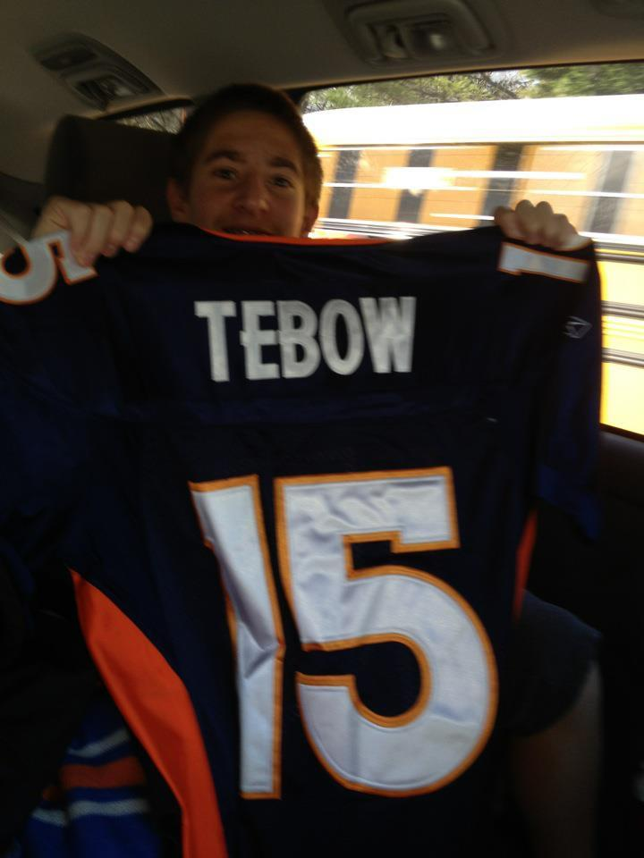
Ben Halperin
Carter Caplan
Jake Feldman
Jason Recht
Alex Klugerman
Hunter Saturn
Could you even ask for a cooler kid?
Yeah, you probably could. But not everyone has 3 magic wishes! But he is one big pimp daddy. Love you Little Fregs! <3
Tal Katz
Is Steven an extremely proud fan? Yes. He loves the Broncos? Of course. A little bit obsessed? Maybe. Does the Tebow every time someone pulls out a camera? No doubt.
Jake Shulman

So, we have all of these new 8th graders who are joining and want to join our chapter. We have all these new-ish AITs who haven’t been recognized yet. The question is…. WHAT THE HELL ARE WE GONNA DO WITH ALL OF THEM?!?! Should we teach them our ways as righteous Alefs? Should we show them how to get along in social interactions that will help them for the rest of their lives? Can we teach them how to be manly men and follow all of the traditions we have celebrated for years on end? Or should we just lock them all in a room with Chief (Alex Danoff) for an hour and see how long it takes for them to kill themselves? Either way, we have to take control of AZA and show all the AITs that Melech is the best. I’ve come up with a few solutions on how to deal with the younger members so we can get the most out of meetings and programs. You see, talking to kids in a relaxed and mature manner takes years to master. That’s why we’re going to brainwash them to listen to everything we say and never argue with upperclassman. You know how loud kids can be when you want them quiet and have something important to say, right? So every time they talk when it’s unwanted, we tape a small tazer to them and it zaps 12 volts right in the family jewels! That’ll shut ‘em up. When they make an unnecessary comment, we get Jake Sorrels to give them a 30 minute to 7 day stern talking to about goals and ideas for the new term……their young brains will implode! But seriously, we are so fortunate to have these new members join our chapter. (And many more to come!) So lets show these rising men how us Melech boys roll. Like The Weather Girls once said, “It’s raining men, hallelujah. It’s raining men.”
KILL THE BABY^
I seriously can’t tell the difference sometimes between him and Brandon. 3-year-apart twins?
Fraternally submitted with undying love for kids not in high school yet (pedophile?), and Melech AZA #2461, I remain Aleph Wyatt Oring

I think we’re gonna get used to Carter, he’s already showing signs that he’s gonna be big in Melech: Arm around a cute girl, watching hockey and cheesin for the camera!
The top 10 reasons to join Einstein AZA
10.
9.
8.
7.
6.
5.
4.
3.
2.
1.all of the above

Fraternally submitted with undying love for Melech AZA #2461 I forever remain, Aleph Ethan Steinberg
A Day in the Life of a JDS student…
- Get to school 1 minute early
- Forget a kippah
- Go get a kippah
- Get marked late. I don’t care. I just threw the attendance sheet ON THE GROUND
- Put my backpack in my locker, it has nothing in it
- Go to class with no books
- Ms. Peterman makes a holocaust joke
- Play temple run with Mr. Smolin
- Rabbi Slater plays guitar
- Ms. Burke plays on her computer. Bloons TD 4
- Mrs. Magali has a panic attack
- SHUT UP MRS. MAGALI
- I go home and eat all the food in the fridge
- Don’t do homework
- Do Moreh stuff
- Go to sleep and dream about Jeffrey Blackman
Fraternally submitted with undying love for JDS, not JDS, and Melech AZA #2461, I remain Aleph Jeremy Etelson.

SUBLIMINAL MESSAGING: LOOK AT THE MELECH PAGE IN YOUR FREE TIME AND TELL ME WHAT I CAN DO TO FIX IT SO THAT ITS MORE APPEALING TO LOOK AT! that is all

Fraternally submitted with undying love for kids not in high school yet (pedophile?), and Melech AZA #2461, I remain Aleph Wyatt Oring
“I’m a marsupial”
This kid soooo flyyyy!
#swag_to_the_max
You mad bro?

